DESCRIPTION.

Using the given dataset find the following.

- The number of movies released between 1950 and 1960.

- The number of movies having rating more than 4.

- The movies whose rating are between 3 and 4.

- The number of movies with duration more than 2 hours (7200 second).

- The list of years and number of movies released each year.

- Total number of movies in dataset .

Initial steps before proceeding

Create a database and use the database for use

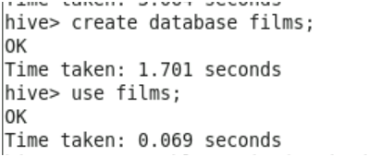

Create a table movies

Load movie data into movies table
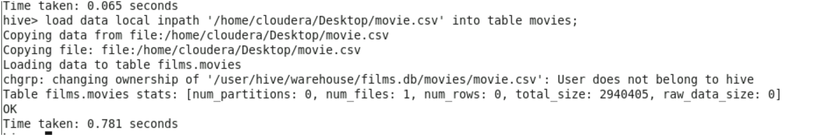

Answers

1.The number of movies released between 1950 and 1960

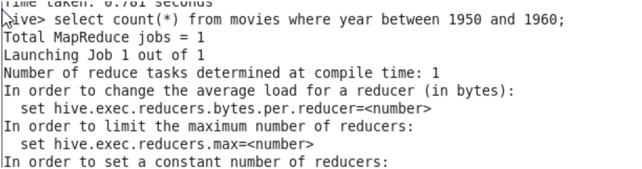
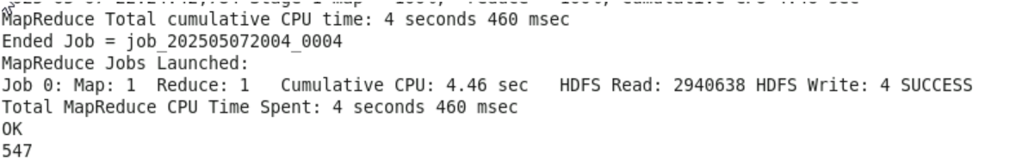

2.The number of movies having rating more than 4
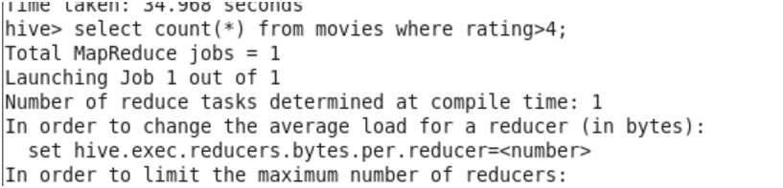

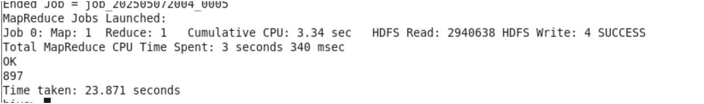

3.The movies whose rating are between 3 and 4
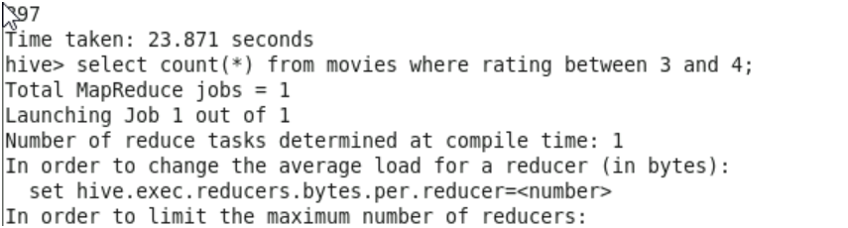

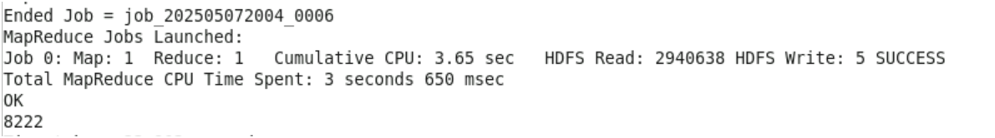
There are 8222 records matches with this condition, so displaying a sample data from them

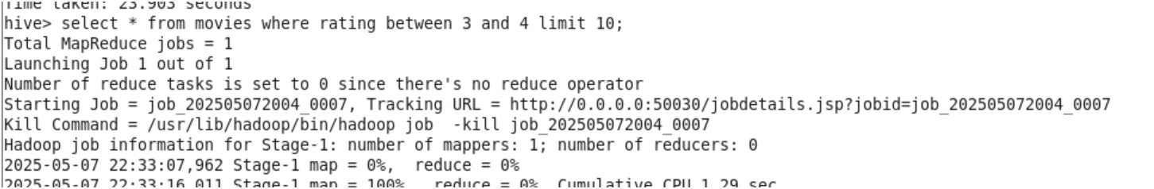

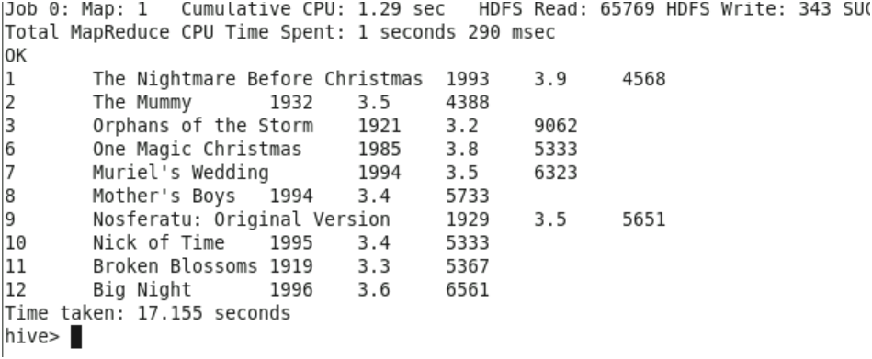
4.The number of movies with duration more than 2 hours (7200 second).

There is change in column name reviews ,it should be duration So changing the column name before proceeding.

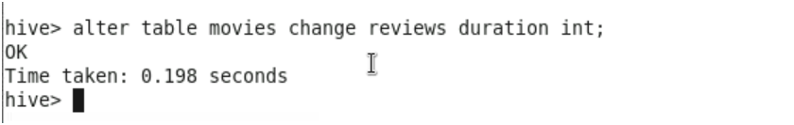

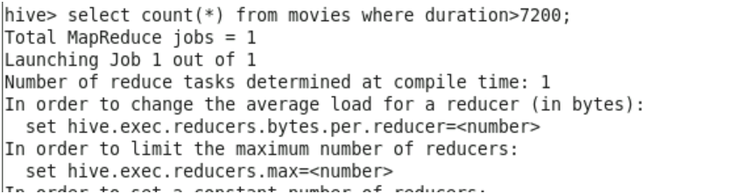

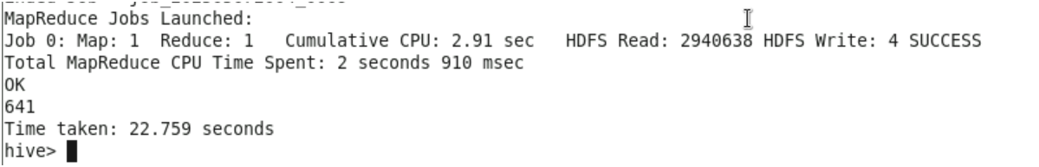
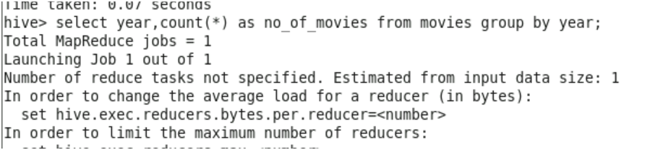
5. The list of years and number of movies released each year

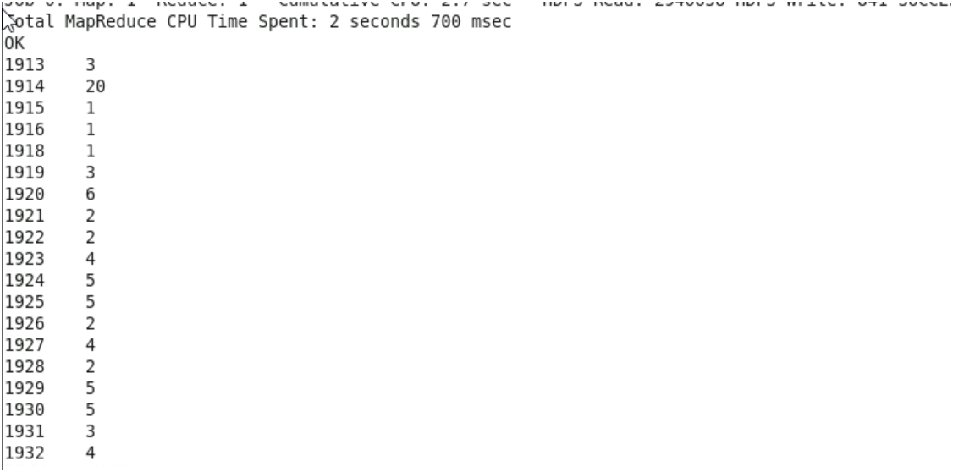

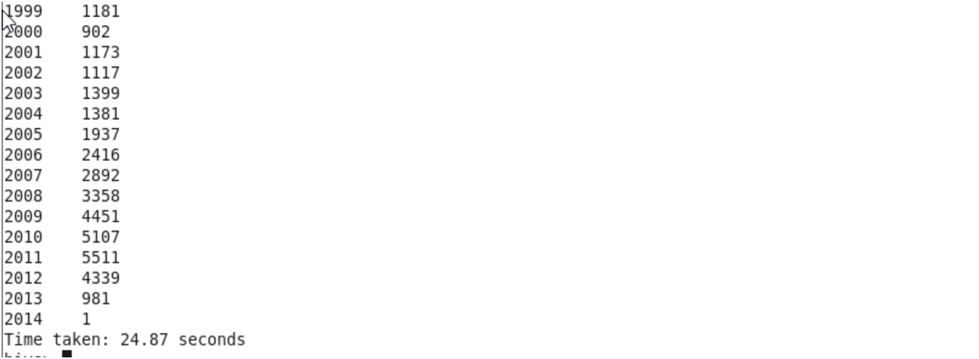

6.Total number of movies in datasets

